|  |  |  |
| --- | --- | --- |
| Database Development |  | |
| By Sam, Marks, Dominic and Jafar | |  |

# Summary

In this project our group has assumed the role of a market intelligence business, tasked with building a database capable of managing projects. We will be using a program called SQL+ to create the database and using an operational mapper called SQL Alchemy to help python capture and utilise data.

We have also compiled a report on NoSQL, in order to explain the alternatives to SQL, in which, we have covered how it is used in business, a critique of NoSQL databases and considerations that need to be made if you were follow this alternative database system route.

Alongside the NoSQL report, we have also investigated Object relational mapping and discovered the strengths and weaknesses of ORM. In the report we also had produce a use case documentation that describes a walkthrough of the continuous service improvement processes.

In conjunction with our database and report tasks, we have developed a continuous service improvement plan in order to maintain a high standard of efficiency and quality in our products.

Contents

1. NoSQL 32

1.1 What is NoSQL? 32

1.2 How is it used in business? 32

1.3 Weaknesses of NoSQL 32

1.4 Key considerations when implementing a NoSQL database 32

2. ORM 42

2.1 What is ORM? 42

2.2 Strenghts of ORM 42

2.3 Weaknesses of ORM 42

2.4 Conclusion 52

3. ITIL 52

3.1 Continuous Service Improvement Plan 52

3.2 USE CASE Documentation 72

4.Conclusion 72

4.1 Overall Conclusion 72

5. References 82

6. Appendix 92

6.1 Gantt Chart 92

6.2 Risk Assessment 102

6.3 ER Diagram 142

# NoSQL

1.1 What is NoSQL?

NoSQL stands for Not Only Structured Query language and NoSQL does not use relations to organise and query data and has recently assumed a position of upcoming category of database management systems. NoSQL’s main characteristic is its non-adherence to relational database concepts. The concept of NoSQL database grew with large internet based companies for example Google, Face book and Amazon who deal with large amount of data. If someone wanted to use a relational database (SQL) for a large amount of data the system might become slow in response time however NoSQL is a non-relational database which distribute data to multiple host better than a relational database.

1.2 How it is used in business

Businesses use NoSQL for business intelligence and analytics. A reason for implementing a NoSQL database is to gain the ability to extract data without conversing certain nodes, allowing information to be gained at higher speeds thus giving the business a competitive advantage. Extracting significant business intelligence from very high amounts of data is a very difficult task to achieve with traditional relational databases. Modern NoSQL database systems not only provide storage and management of business application data.

NoSQL can also be argued to more efficient the traditional SQL databases as they are easier to manage, largely because they have been created from the bottom up with efficiency as a core design function.

1.3 Weaknesses of NoSQL

One of its greatest advantages is also one of NoSQL’s greatest weaknesses; being open-source. This can also be considered a disadvantage as there are not many reliable standards for NoSQL databases yet. Getting a particular implementation to work with existing infrastructure can therefore be something of a problem. NoSQL databases have evolved to meet the scaling demands of the business. Therefore, most of their features are focused towards the demands of these systems.

However, data in a system has value to the business that goes beyond the insert-read-update-delete cycle of a typical database. Businesses extract information in corporate databases to improve their efficiency and competitiveness.

1.4 Key considerations when implementing a NoSQL database

One of the key considerations when implementing a NoSQL database is performance. Downtime can cost you a lot of revenue, large amount of data must move at high speed. Performance of your database should be high on the list of requirements for releasing a NoSQL database. Another key consideration when implementing a NoSQL database is availability. Your data should never go down, therefore there should be no single point of failure in your NoSQL database, and therefore ensuring database is always available.

Another key consideration when implementing a NoSQL database is manageability.  The difficulty of a NoSQL database should be kept at a small amount. Make sure that the management and development required to both maintain and maximize the benefits of moving to a NoSQL database are attainable. Another key consideration when implementing a NoSQL database is cost. This is surely the main reason for making the move to a NoSQL system is that relational database can become expensive. Deploying NoSQL properly allows for all of the benefits above while also lowering costs.

# ORM

2.1 What is ORM?

ORM stands for Object Relational Mapping. Object Relational Mapping is a tool that lets you query and modify data from a database using an object model. It is a completely normally library written in a language in your choice that summarises the code needed to modify the data, so you do not need to use SQL, but directly using an object of a language of your chose for example SQL Alchemy can be used in conjunction with Python.

2.2 Advantages of ORM

An advantage of Object Relational Mapping is that it speeds up development as it eliminates the need to repeat SQL code which allows more time for the developers to do more time to work on other pieces of work. As it speeds up development it therefore reduces development time which means the group of developers will be more time efficient. Another advantage of ORM is that it reduces development costs as the groups do not have to employ a SQL specialist or worker. Another advantage of ORM is that it overcomes service provider specific SQL differences as the ORM knows how to write specific SQL so the developer does not have to.

2.3 Disadvantages of ORM

A disadvantage of ORM is that there is a loss in productivity from the worker as the developer will have to learn to program with the ORM. Another disadvantage of ORM is that the developers may lose understanding of what the code is actually doing as the developer is more in control use SQL. Another disadvantage is that ORM’s tend to be slow. Another disadvantage could be that it is hard to carry out complex queries.

2.4 Conclusion

Overall, I believe ORM is beneficial for developers as ORM tools provide the developer an object oriented query language. This allows the developer focus on the object model and not to have to be concerned with the database structure or SQL syntax. The ORM tool itself will translate the query language into the appropriate SQL syntax for the database.

# ITIL

3.1 Continuous Service Improvement Plan

*The Continuous Service Improvement Model*



What is the vision of the data processing tool?

We are a business intelligence company that specialises in the technology industry; our main aim is to provide information (data) for companies in the technology sector so they can make better business decisions. As a business intelligence company we have to gather and analyse information (for example financial) specifically for the main purpose of accurate and confident data to make the right decision for the business to try and improve operation of the firm and profits. The vision of the data processing tool is to allow us to provide our customers with a reliable and efficient financial data. The objective of our data processing tool is to provide financial information for organisation in a range of industries so we (service provider) can use the financial data to compare and/or analyse financial figures to see how the customers are performing in terms of other firms in a range of industries.

Where are we now with the data processing tool?

Currently, the data processing tool downloads financial statements (financial position statement and income statement) automatically. The data processing tool filters the data according to the information required for the customer’s sector. The data is sorted for easy human lookup. It is processed to extract relevant business insights for example Gross Profit and the information is stored as a CSV file for archival purposes. However a problem for the data processing tool is that it does not output other financial data for example ratios and other financial statement.

Where do we want to be?

Our main targets is to create a database functionality in our data processing tool program as this will allow us to add other types of financial data (for example ratios and other financial statement) of businesses in a particular sector / industry manually. Another target we would like to achieve is that we want to create a flexible database to match the Service Level Agreement. Another target we would like to achieve is that we want to deliver 24/7 support for our workers (according to the service level agreement) for that data processing tool.

How do we get there?

One way to achieve our target could be to create a survey so we can see how good or bad our customer satisfaction is. By creating the survey we can see if our former and current clients were or are happy with our service. After analysing the survey we can see the strengths and weaknesses of our service and how can we improve our service to our clients. Another way we can achieve our targets could be to invest physical capital to the business so we can employ more workers so we can implement the database and maybe outsource our jobs so we can give 24/7 customer support to our clients.

Did we get there?

Metrics for successful improvements:

Metric: Errors reported quickly – SLG: 99%, 20-25 minutes

Metric: Time to repair to bugs/errors – SLG: 95%, 12-24 hours

Metric: Customers Satisfaction – SLG: 99%, Annually (year on year)

Metric: The API is available - SLG: 98%, 24/7/365

How do we keep the momentum going?

To keep on improving continuously and to have a competitive advantage over our competitors must always find new ways to try and improve the services we provide to our customers. We also must consider introducing new services in our catalogue that we provide to our clients to give us a competitive in our industry. We will keep on gather information from the customers satisfaction surveys so we can highlight our strength but also identify our weaknesses and how we can improve it. We should also implement new technologies in our service to make sure the service we provide is up to date and efficient.

USE CASE Documentation

|  |  |  |
| --- | --- | --- |
| **Use Case Title:** | CSI | |
| **Description:** | | A hypothetical walk through of the CSI processes. |
| **Actors:** | | Service Provider |
| **Preconditions:** | | 1. The business must have a service to provide to the user. 2. There must be some sort of problem with the service 3. The business must have customers who have purchased the service. |
| **Normal Flow:** | | 1. The service provider must determine an improvement opportunity for the service. 2. The service provider must develop a team and direction. 3. The team must identify stakeholders and the stakeholders’ needs. 4. The team should map current processes or identify revolutionary ideas. 5. The team should then try to optimise process. 6. The service provider should then test and implement the revolutionary ideas the team has created. 7. The service provider must measure the process performance. 8. The service provider must standardise and monitor each process. |
| **Post conditions:** | | 1. Better customer satisfaction 2. The service is more efficient. |
| **Alternative Flows:** | | The service provider or team cannot find anyways to improve the users.  The service provider does not have the resources to create a team.  The team or service provider cannot identify the stakeholders of the service and their needs. |

# Conclusion

4.1 Overall conclusion

In conclusion in this project we have to develop a database to help manage its projects. We will be used a program called SQL+ to create the database and used the programming language python with SQL Alchemy to query the data. In the report we had to research about NoSQL, how it is used in business, critique of NoSQL database and consideration that needs to be made if you were to be introduced in business. We also researched about Object relational mapping and discovered the strengths and weaknesses of ORM. In the report we also had produce a use case documentation that describes a walkthrough of the continuous servicer improvement processes. We also had to create a continuous service improvement plan to show how we are going to keep on improving the service we give to our clients so we have a competitive advantage against our competitors.

# References

Anon. (2013) *ITIL â€“ Introducing Continual Service Improvement* [online] 1st edn. London: ucisa. available from <https://www.ucisa.ac.uk/~/media/Files/members/activities/ITIL/continual_service_improv/ITIL_Introducing%20Continual%20Service%20Improv%20pdf.ashx> [16 February 2015]

Block, G. (2006) *Ten Advantages Of An ORM (Object Relational Mapper)* [online] available from <http://blogs.msdn.com/b/gblock/archive/2006/10/26/ten-advantages-of-an-orm.aspx> [23 February 2015]

Felata, M. (2012) *The Advantages And Disadvantages Of Using ORM* [online] available from <http://stackoverflow.com/questions/4667906/the-advantages-and-disadvantages-of-using-orm> [23 February 2015]

Greene, N. (2015) *The Five Key Advantages (And Disadvantages) Of Nosql | Green Data Center Blog* [online] available from <http://greendatacenterconference.com/blog/the-five-key-advantages-and-disadvantages-of-nosql/> [11 February 2015]

guru99, (2013) *What Is Nosql ?* [online] available from <https://www.youtube.com/watch?v=qUV2j3XBRHc> [11 February 2015]

Harrison, G. (2010) *10 Things You Should Know About Nosql Databases* [online] available from <http://www.techrepublic.com/blog/10-things/10-things-you-should-know-about-nosql-databases/> [11 February 2015]

McQuerrey, L. (2013) *Measurable Objectives In A Business* [online] available from <http://smallbusiness.chron.com/measurable-objectives-business-61314.html> [16 February 2015]

Planet Cassandra, (2015) *Nosql Databases Defined & Explained* [online] available from <http://planetcassandra.org/what-is-nosql/> [11 February 2015]

Stackoverflow.com, (2011) *What Is An ORM And Where Can I Learn More About It?* [online] available from <http://stackoverflow.com/questions/1279613/what-is-an-orm-and-where-can-i-learn-more-about-it> [23 February 2015]

UCISA, (2013) *The Continual Service Improvement Model* [online] available from <https://www.ucisa.ac.uk/~/media/Files/members/activities/ITIL/continual_service_improv/ITIL_Introducing%20Continual%20Service

# *Appendix*

6.1 Gantt chart

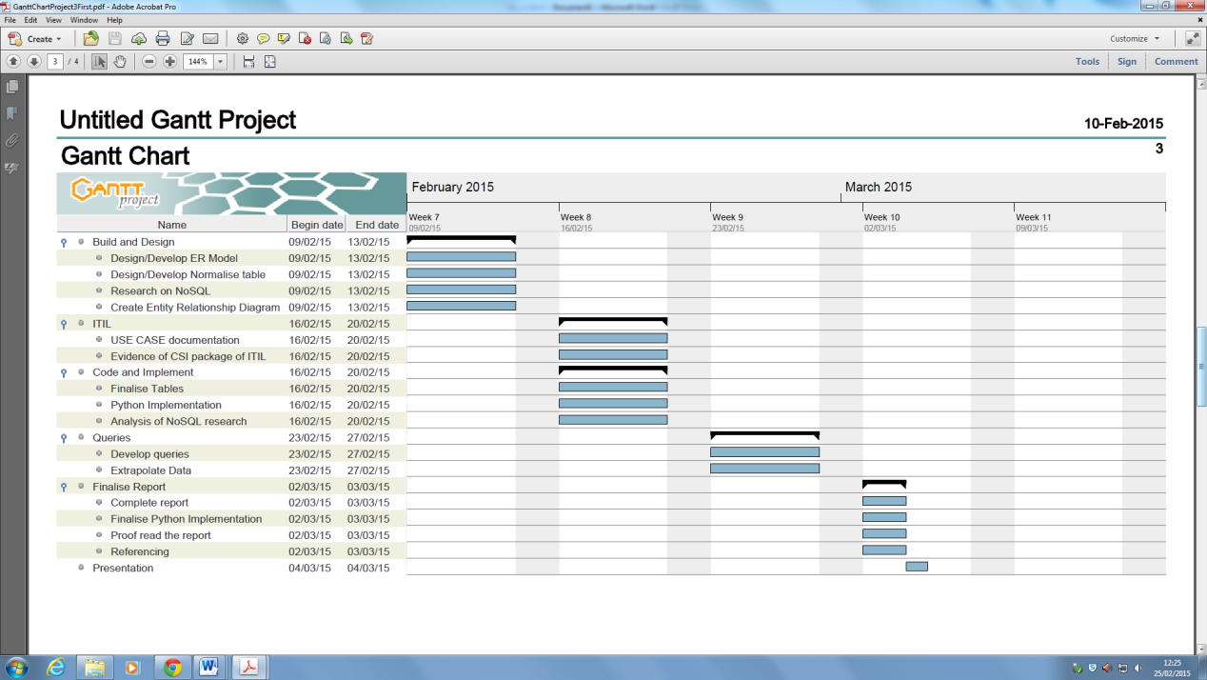Before starting the Project

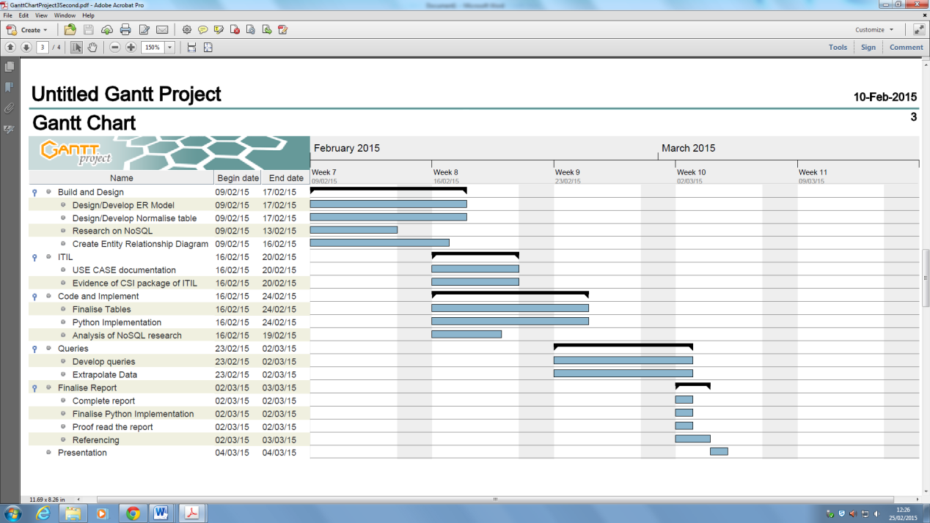During the project

**6.2 Risk assessment**

| No. | Date Identified | Risk | Probability (L,M,H) | Impact (L,M,H) | Effect on Project | Risk Reduction Actions Proposed & Actual | If it happens: Triggers & Actions Proposed & Actual |
| --- | --- | --- | --- | --- | --- | --- | --- |
| 1 | 24-Nov-14 | The project supervisor does not attend a project session and check on how the group is doing. | Medium | High | This could lead to confusion about the project from the team members which could stop the progression of the project. | The project manager should email the project tutor every week on the progress of the project and any problems the team is having. | Triggers  The project tutor does not turn up for a project session.  Actions  Tell one of the lectures that your project tutor is not hear and ask if they have seen him/her and if you can help the team if they are having a certain problem from the project. |
| 2 | 24-Nov-14 | A group member has finished his task early and waiting for his next task to complete. | Medium | Low | It is a waste of resources as the team member can help the other team members which will improve the speed of the project. | Improve the Gantt chart so when a team member has finished their task early they can start another task that does not depend on other tasks being finished. | Triggers  One of the team members has completed their work at waiting everyone else to finish their tasks.  Actions  Tell the team member to help the other members with their work or the team leader should give him a new task. |
| 3 | 24-Nov-14 | Loss of electrical power | **Low** | **Low** | The team members will not be able to do/complete their work | Tell the lecturer, IT support staff or team tutor that there seem to be a power problem and the computers are not working. | Triggers  No electricity power.  Actions  Ask the lectures/project tutor if the group can work someplace else so the group can continue with their programming and complete the report. |
| 4 | 24-Nov-14 | **Forgetting to reference the research.** | **High** | **High** | Failure to reference the information you got your information could lead to the group project being grade as a fail. | If a team member wants to use a piece of information they should open the Google document and state the date they used it, where they got the piece of information from. Make sure to use Harvard referencing. | Triggers  A small or no reference list, attached as the bottom of the report.  Actions  Use the website [www.citethisforme.com](http://www.citethisforme.com) which is an easy online tool that references all your information. |
| 5 | 24-Nov-14 | The code the group has created has errors. | High | Medium | If the python code for the program the group is creating has errors the program would not run or the program would not run properly. | When a group member commits a piece of code to GitHub they should test the code for any errors such as Syntax. | Triggers  Running the program and highlight the errors in the code.  Actions  Read through the code and try to spot any errors in the code and try to correct them. If the other groups member cannot find the errors in the code, the project manager should ask for help for help from the project tutor. |
| 6 | 24-Nov-14 | People not contributing to the group code. | Medium | High | If team members do not contribute to the group code the group will not be able to summit the code to the project tutor. | Make sure all team members are using GitHub when contributing their own piece of code. So the project manager can see who have contributed to the group project and who has not. | Triggers  A small amount of code for the group project and little programming activity from team members.  Actions  Make sure all team members commit their python code on GitHub. If a team member does not contribute, the project manager will have to talk the group member on why he/she is not contributing to the project. |
| 7 | 24-Nov-14 | A group member being ill and not being able to come in and join the group tutorial. | **High** | **High** | May put delays on the project and the team member will have to catch up on what he miss the day he was sick. | Create some sort of document like an agenda or meeting minutes which shows what we did in this project session. | Triggers  A member not turning up to a project session.  Actions  Email or talk to the group member asking where he is. If he does not respond the project manager should create a document for the ill team leader on what the team did in the project session. |
| 8 | 24-Nov-14 | Loss of electrical power | **Low** | **Low** | The team members will not be able to do/complete their work | Tell the lecturer, IT support staff or team tutor that there seem to be a power problem and the computers are not working. | Triggers  No electricity power.  Actions  Ask the lectures/project tutor if the group can work someplace else so the group can continue with their programming and complete the report. |
| 9 | 24-Nov-14 | A member was not attending group project workshops. | Low | High | Unable to complete key tasks | Highlighted the importance of project to the team member and told the lecturer that the team member was not attending group meeting. | Triggers  Reports of absence, or diversion of staff to other work  Actions  Identify alternative resources in case of unexpected absence. Investigate whether extra resources could either be involved or shadow any work dependent on a single member of staff |
| 10 | 24-Nov-14 | Losing USB or USB being corrupted. | Medium | High | Losing our USB will have a big effect on the project because all of my research for the report is on the USB. | Scanned my USB and my personal laptops for viruses, spyware, malware, etc. I also backed up (copied) my files from my USB to my Google drive and One drive account. | Triggers  Cannot find my files on my hard drive or USB.  Actions  Download my backed up files to my computer from Google drive or One Drive so I can continue my research from the report and my group members can continue with their part of the project. |
| 11 | 24-Nov-14 | Not meeting an internal deadline. | High | High | Not meeting an internal deadline will have a bad effect on the group project as some tasks are dependent on some tasks being finished. | Dedicated more time to the piece of work I had to give in to the group so they can start on their own tasks. | Triggers  Noting meeting the internal group deadline.  Actions  Apologies to the other group members for not completing my task.  Adjust the project plan (Gantt chart) so I can see how much extra days I can have to complete the project. |

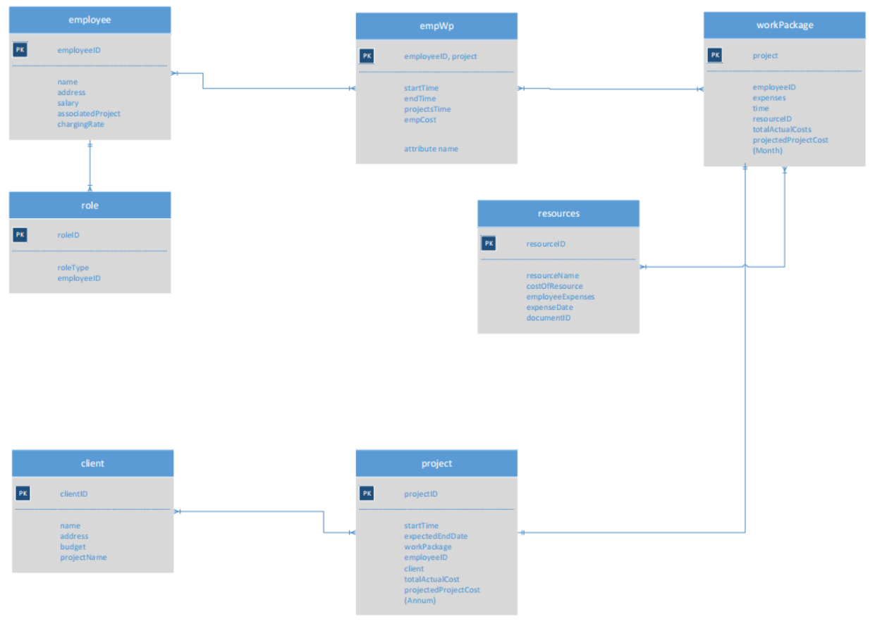**6.3 ER Diagram**